CHICKEN CACCIATORE -
Ingredients:
- 1-1/2 lbs (8 small thighs) of skinless, trimmed bone-in chicken thighs (from good butcher) – trimmed with fat taken off (don’t have to cut into pieces)
- Brine overnight in closed container or bag– (1/4 cup kosher salt, ¼ cup sugar and 8 cups water)
- 3 garlic cloves, smashed and chopped (or more)
- salt & pepper
- flour
- 2-3 tablespoons olive oil (may need more throughout process of cooking dish)
- 1-1-1/4 lbs small mushrooms whole or sliced in half– about 1 inch diameter
- Two onions sliced (regular – not sweet – organic) about 2-3” in diameter
- 1-1/2 – 2 cups chicken stock or consomme
- Pizza sauce – 1-1/2 cups (you can use regular tomato sauce)
- 1-1/2 - 2 cups of Marsala wine
- ¼-1/2 cup of unsalted butter for thickening (I didn’t need that)
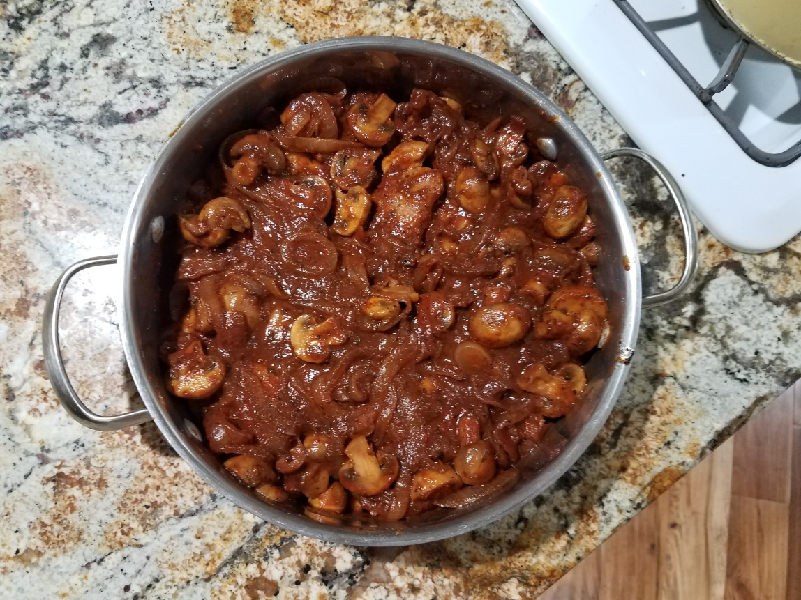

Take chicken (chicken thighs with bone trimmed by the butcher).
Season the top with salt and minced garlic. Dredge all the rolls in flour and brown in oil on one side (about 15 minutes). Turn over and brown more until nice and brown. (Because my thighs don’t have skin it may take longer to brown) Add chicken stock, salt, pepper and parsley. Bring to vigorous boil and then carefully simmer on the stove top until the centers of the pieces get to 165 degrees moving chicken around. Simmer more (20 minutes) until stock is reduced. If chicken is not cooked enough take out chicken and put in oven for 15 minutes covered and 15 minutes uncovered and then put aside.
In the SAME PAN THAT YOU COOKED CHICKEN IN:
With a wooden spoon scrape caked drippings and add about 1-2 tablespoons of olive oil make very hot. Lower heat a little. brown and caramelize onions for about 20 minutes mixing with wooden spoon constantly. Then add lots and lots of cut up mushrooms (1-1/4lbs) and salt and cook for about 5 minutes – mixing while cooking. While still very hot put in ¼ cup wine to start and fizzle, then put 1-1/4 cups of Marsala wine and cook in pan for about 20 minutes or more to reduce. Allow the alcohol to steam off, then add 1-1/2 cups pizza sauce and cook to allow to reduce more (add a mound of butter --do not boil butter – if not thick enough. Mine didn’t require butter.) Then immediately marry the two (chicken and sauce) and cook another 15 minutes all together (or not) – just eat it. Or put in fridge and heat up again. Top with basil leaves if you like.

Ed: Note –

Variations and tips:
I feel I could use regular tomato sauce because the sauce was nice and thick with the Pizza sauce.
I probably will have to dilute the sauce when I heat it up with more chicken stock so it won’t be too thick.
I don’t think I need so many mushrooms

